Creating a Chatbot

Contents

Getting started 2

Accessing the management console 2

Create the chatbot 3

Modify the chatbot 6

# Getting started

You have been sent an email for 2 courses:

* AWS Academy Cloud Foundations. This provides the learning content, which the DAP lists as "homework" starting next week.
* AWS Academy Learner Lab. This provides the console access previously used in AWS Educate

For this activity, we will be using “AWS Academy Learner Lab”

Log into AWS academy using the link provided in the email sent to your student account. The link is probably: [https://awsacademy.instructure.com/](https://awsacademy.instructure.com/courses/4668)

# Accessing the management console

|  |  |
| --- | --- |
| Select the “Modules” hyperlink at the bottom of the page |  |
| Select the “Learner Lab” module |  |
| You should get an agreement. Select “I agree”  If the agreement does not appear, click “Modules” again in the top left. |  |

|  |  |
| --- | --- |
| You are now in the lab environment, ready to start the lab.  Select “Start Lab” |  |
| The lab environment will take a while to power on |  |
| Once powered on, you will get a console similar to the right |  |
| Click the “AWS” link in the top left to access the management console |  |

# Create the chatbot

1. In the search bar, type in Lex and select “Amazon Lex” to enter the Amazon Lex Dashboard

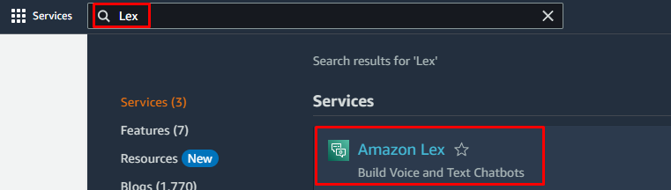

1. Press the orange “Create Bot” button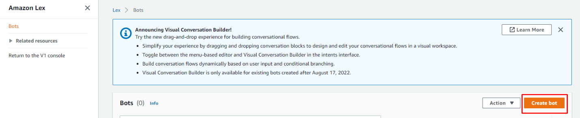
2. You will now be at the Create bot settings screen. Select Start with an example and enter the following Basic Information

* Example bot: BookTrip
* Bot name: BookTrip
* Description: Leave this blank
* IAM Permissions: Create a role with basic Amazon Lex permissions
* COPPA: No

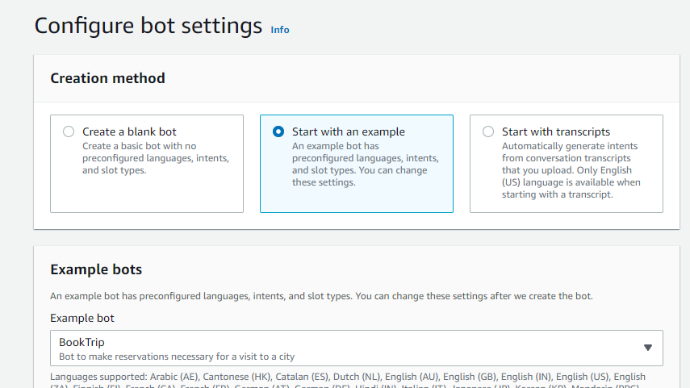

1. Press the orange Next button
2. You should now be in the Add language to bot screen. Leave all the settings as default and press the orange Done button

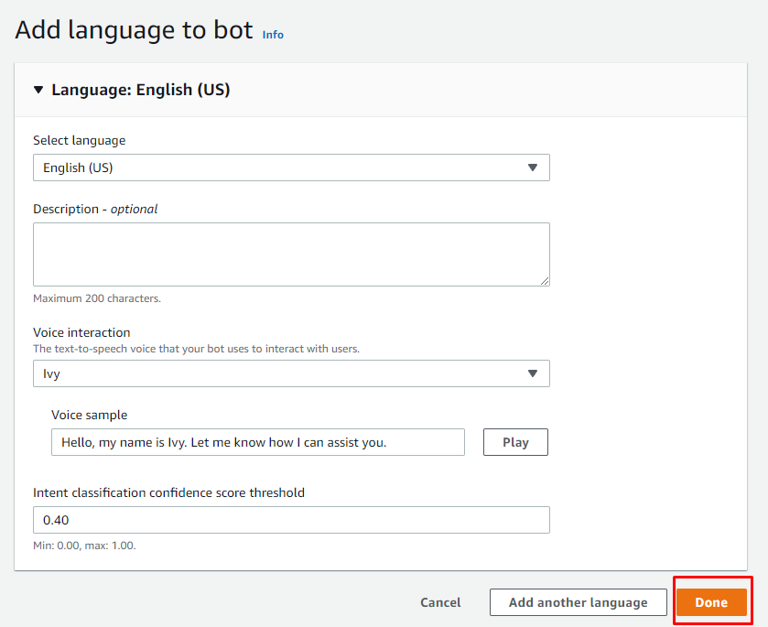

# Modify the chatbot

You should now be in a screen that says Intent: BookHotel. An intent is an action that fulfills a user’s request. We are going to modify the defaults slightly

1. Click on Visual Builder at the bottom of the screen

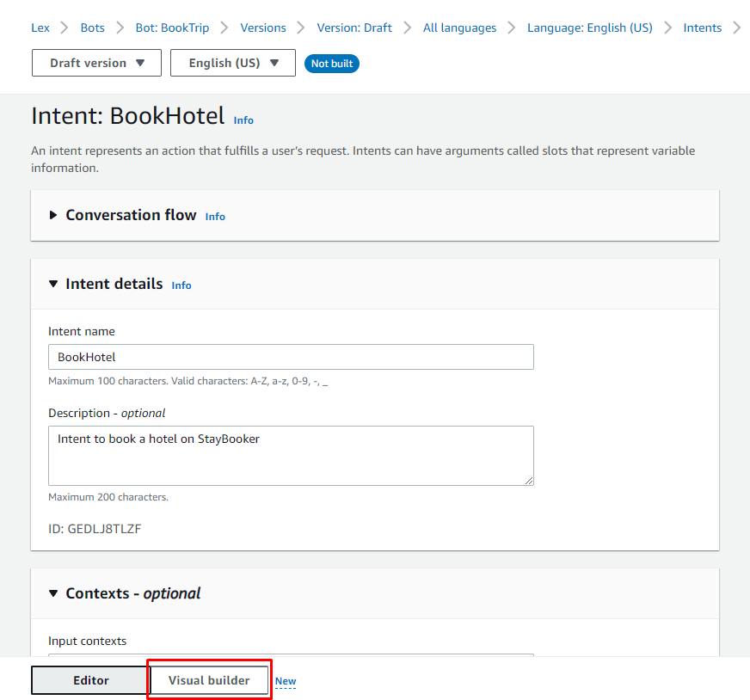

1. If prompted to Leave without saving, press the orange Leave button

You will now see a series of what are called slots, which are individual steps after each interaction. We want to modify the final slot called Confirmation

1. On the Confirmation slot, press the white square with a pencil in it (it is small to see) and a confirmation menu screen should open

1. You will notice that the Confirmation response: Yes – *optional* is blank. We are going to enter a response in here. Within the blank field, type in the following

Thank you, your booking has been confirmed

1. Press the orange Save intent button



1. Press Confirm when prompted

1. Close the confirmation screen

1. Press the Build button

1. Once the build is complete, press the Test button and your Chatbot should open

1. Enter the following text in the type a message field. Please remember to wait for an automated response before entering your next answer

* Book a trip
* Paris
* Today
* 3
* King
* Yes

If all is working, you should get a message saying Thank you, your booking has been confirmed.

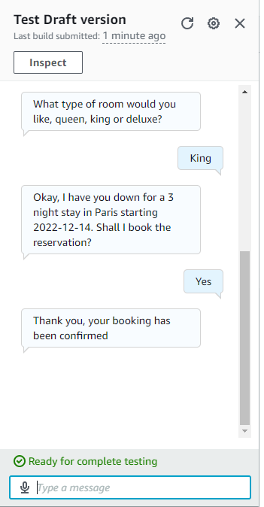

Well done. You have now completed creating a chatbot using the AWS Service called Amazon Lex.